
ОБЩЕСТВО С ОГРАНИЧЕННОЙ ОТВЕТСТВЕННОСТЬЮ
«ЛАЗЕРТАГ»

ПАСПОРТ

Смоленск

LIMITED LIABILITY COMPANY
LASERWAR

SPECIFICATION

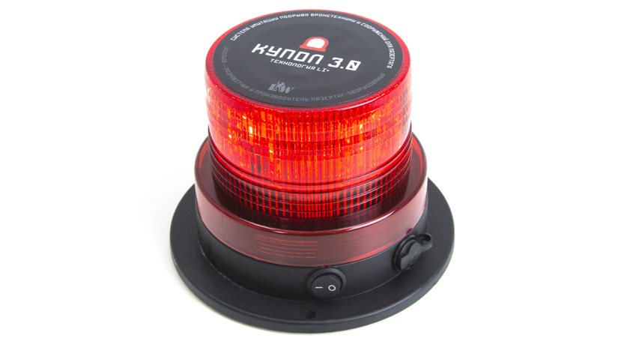

Game set

ARMOR DISRUPTION SYSTEM
DOME 3.0

7. Guarantee obligations
The manufacturer guarantees the reliability of the operation of an individual LASERWAR set if the consumer has complied with the conditions of use. Technical support is provided within 12 months of the sale date. The manufacturer undertakes to replace or repair an individual set of equipment free of charge, if the customer has complied with the rules for the device transportation, storage, operation and delivery of defective equipment to Smolensk City.

8. Contact information

Official website:
www.laserwar.com

E-mail:

info@laserwar.com

help@laserwar.com

Skype:

info@laserwar.com

help@laserwar.com

Purchase date: _________________________

______________________________________
signature

Dear Customer!

Our company welcomes and thanks you for the decision to buy our products, and is confident that the purchased device will bring you a long-term pleasure. The warranty certificate establishes the guarantee of the product in the amount provided for by the Law on consumer protection of the Russian Federation.
This warranty certificate is valid for 12 months from the purchase date of the product, and is subject to the guarantee terms.
Warranty Terms:
1. The guarantee is effective upon presentation of this coupon, which shall contain the serial number of the product and the date of its purchase, confirmed by the service centre.
2. These guarantee obligations apply to products acquired only from the official LASERTAG representative or the official dealer.
3. The present guarantee is invalid if the product deficiencies have occurred in the following cases:
- failure to comply with Operating instructions;
- mechanical damage;
- penetration of extraneous items, liquids, etc.;
- animal activities;
- unauthorized access to the parts of the game set by non-authorized persons;
- use of the product for purposes for which it hasn't been made;
- Acts of elements (natural disaster, fire, accidents, etc.);
- the game set malfunction in case of faulty power network and/or poor care of the product.
4. If the warranty certificate is lost, no duplicate is issued.

2
7
Information on the repairs performed during the maintenance period (completed by the Service centre performing the warranty repair works).

Date: __________________  Completed work: _____________________________________________________________________  Service centre stamp | Date: __________________  Completed work: _____________________________________________________________________  Service centre stamp
Date: __________________  Completed work: _____________________________________________________________________  Service centre stamp | Date: __________________  Completed work: _____________________________________________________________________  Service centre stamp
Date: __________________  Completed work: _____________________________________________________________________  Service centre stamp | Date: __________________  Completed work: _____________________________________________________________________  Service centre stamp

1. Description
The DOME is attached to the vehicle and is designed to virtually damage the vehicle.

2. Scope of application
The DOME is used in scenarios designed to use motor vehicles.
3. Contents of delivery:
- DOME - 1 pcs.
- Specification - 1 pcs.

4. Basic technical Data
Height, mm | 130
Diameter, mm | 130
Battery life | Up to 48 hours.
Battery type | Li+ (2.2 Ah; 7.4 V)
Battery type | Li+ (8.4V; 1000 mA)
Weight, kg | 0.47

5. Maintenance
All parts of the set must be treated with care if you want the equipment to function properly. Avoid contamination and damage to the IR diode and the photosensor. There shouldn't be any moisture inside the frame. Don't hit the device.

3
6
6. User's manual
You must download the configurator program to change the game set settings.
Visit the www.laserwar.ru site to download it.
Connect the USB base to your PC and turn on the DOME. The device will automatically switch to the admin mode. Change settings and save them.

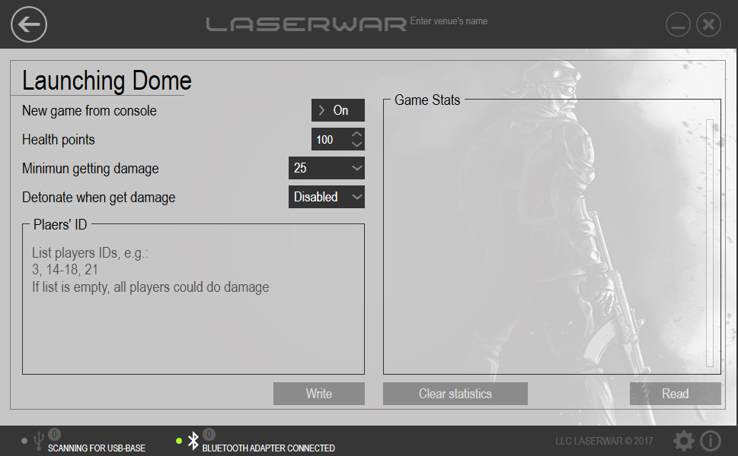

Equipment Maintenance Rules
1. Weather conditions. At the course of manufacture, we make different tests to see how well the equipment works under different weather conditions. Despite this, we strongly recommend that the equipment shouldn’t be used in the rain and at temperatures below -20 ° C.
What should I know when using the equipment in poor weather conditions?
The most important thing is to avoid getting moisture inside the device. If this happened, turn off the device, dry the equipment at room temperature for at least two hours.

2. Power source. The device uses 2.2 Ah lithium batteries.
To recharge the device use only Li+ chargers.
Charge the device under supervision no more than for three hours.
It is necessary to store the equipment in a well-ventilated room at temperature from + 18°C to + 30°C and relative humidity of 45-65%.
The warranty is 14 days for batteries, speakers, and IR modules. These components are expendable materials.

PLEASE NOTE! In the case of improper operation of the accumulator (charging by an unrelated type of a charger), the warranty doesn't cover the battery!

4
5

